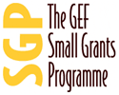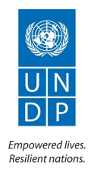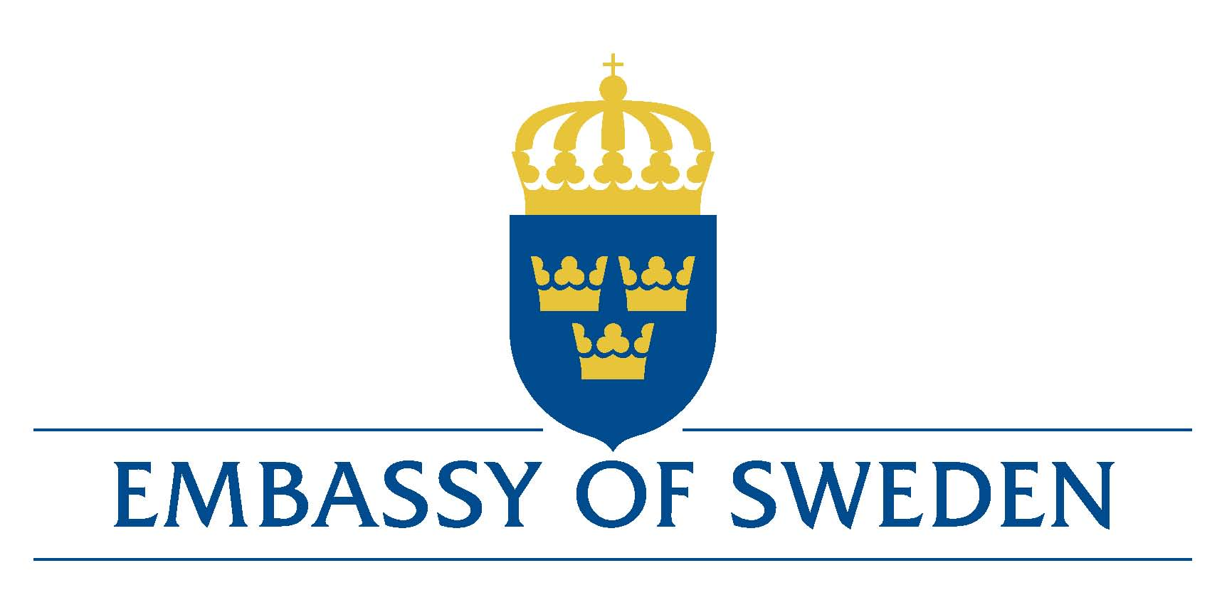

Annual Project Progress Report

United Nations Development Programme
Cambodia
[Cambodia Community Based Adaptation Programme]

[01-01-2011 – 31-12-2011]

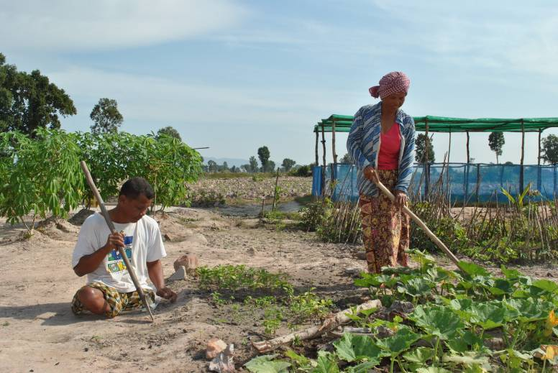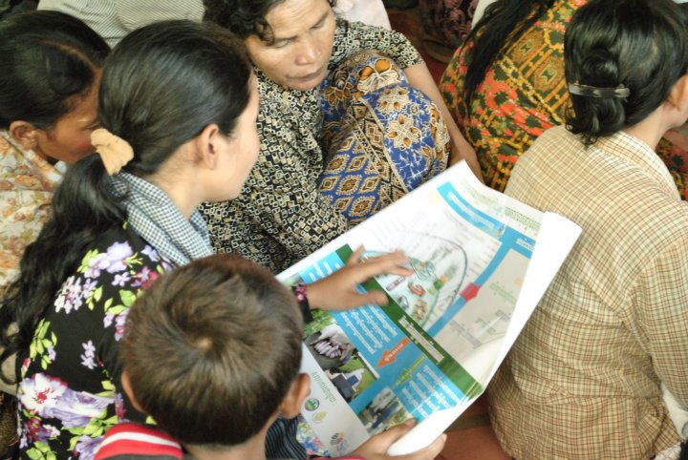
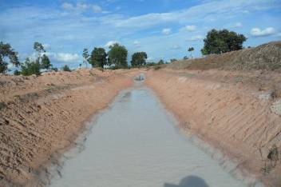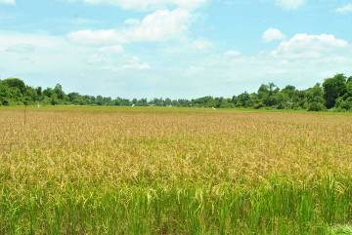

Project ID: 00077094
Duration: 3 years
Total Budget: US$2,577,090 (SEK 17,300,000)
Implementing Partner: UNDP
Country Programme Outcome: National and local authorities, communities and private sector are better able to sustainably manage ecosystems goods and services and respond to climate change

Table of Contents
I. Executive summary 3

II. Implementation progress 6
Capacity Development 12
Gender 13
Lesson learned 13

III. Project implementation challenges 14
a. Updated project risks and actions 14
b. Updated project issues and actions 21

IV. Financial status and utilization 21

I. Executive summary

The Cambodia Community Based Adaptation Programme (CCBAP), funded by Sida has an overall objective of improving community based adaptation and climate resilience in vulnerable communities in flood/drought prone provinces of Cambodia. The CCBAP started on 10 December 2010 and will end on 31 December 2012. The CCBAP has three main outputs: (1) improved necessary capacity within NGOs, CBOs and local communities to implement community adaptation measures; (2) mainstreaming of adaptation to climate change at commune level; and (3) lessons learned and good practices documented and shared to influence changes of policy and programme development. The CCBAP is being implemented under the existing established UNDP/GEF/SGP implementation infrastructure.
Since the launch of the programme in January 2011, 46 proposals have been approved by SGP NSC meetings, enabling 38 LNGOs and 8 CBOs to plan and implement adaptation measures in 353 villages, 97 communes, 48 districts and 18 provinces of Cambodia. This was achieved through intensive efforts to raise the profile of the programme, capacity building of LNGOs and CBOs and through two rounds of proposal selection processes.
As a result of the first round call for proposals, 27 projects were funded, which cover 242 villages, 62 communes, 29 districts and 17 provinces. Based on the VRA analysis, key interventions had been incorporated and implemented in parts of CCBAP target areas. In addition, a high number of concept notes and proposals indicated a high level of interest and strong demand of both vulnerable communities and LNGOs/CBOs to plan and implement CBA measures. Therefore, in order to fully meet the demands of the communities, an additional fund were approved by Sida. Based on the same project selection process, 19 projects were approved in the second round, which cover by 84 villages, 22 commune, 9 districts and 1 province. With the additional support funding from Sida, the CCBAP were able to augment its impact and support to more vulnerable communities who are actively participating in the implementation of CBA projects and testing climate change resilience techniques.
The proposals were approved on the basis of the VRA conducted in the target villages where consensus on adaptation responses were built among local stakeholders and of field validation and review meetings by SGP team and SGP NSC members. The Analysis of the 46 projects showed that the majority of the project interventions are mainly based on findings of VRA. These interventions, which are aiming at building adaptive capacity of targeted community members, include the following: (i) rehabilitation of water infrastructure such as existing dams, ponds and canals, and wells; (ii) strengthening of water resource management structures; (iii) capacity building and establishment of community fisheries, community forestry; (iv) livelihood improvements such as promotion of resilient agricultural techniques, community-based ecotourism and saving group establishment for job creation; and (v) climate change awareness raising and mainstreaming climate change priorities into commune development plans.
To assist NGO applicants in conducting VRAs and developing good quality proposals, three training workshops were organized. In total, 130 representatives (105 male and 25 female) from 85 LNGOs and CBOs have increased their understanding and knowledge on Vulnerability Reduction Assessment and Proposal development. As the results, the LNGOs and CBOs were able to conduct VRA and develop proposal that met selection criteria. In addition, capacity building though coaching were provided to 79 LNGOs and CBOs by NSC members and SGP team during field appraisal visits to the project sites.
119 representatives (77 male and 42 female) from 46 selected LNGOs and CBOs have increased their capacity in project and financial management from 4 training workshops, which were organized by UNDP SGP CCBAP team, on project implementation, progress reports and finical reports included procurement processes and other financial forms.
To further strengthen knowledge and skills, 91 representatives (79 male and 12 female) from 46 selected LNGOs and CBOs actively shared and learned from experiences on CBA project design and implementation at the reflection workshop on Community Based Adaption project, which was organized by SGP team.
National Workshop on Mainstreaming Community Based Adaptation into Sub-national level was designed as a forum where 108 commune council representatives and 48 selected LNGOs/CBOs representatives were given an opportunity to learn, exchange, and network with each other. As a result, National Committee for Decentralization and De-concentration Secretary (NCCD) was interested and committed to instructing 97 communes to integrate community adaptation measures into commune development plans and commune investment plans.
In addition, feedbacks and inputs received from the national workshop facilitated the refinement of the VRA guide which was subsequently integrated into commune development planning processes.
The workshop also raised the profile of successful cases of CCBAP implementation through national and English language newspapers and magazines.
SGP/CCBAP team attended regional and national workshops and forums to share and learnt new resilience technologies in the 1st Meeting of Climate Change Adaptation Demonstration Projects in the Lower Mekong Basin sharing lessons and experiences in Vietnam, organized by Mekong River Committee, and a final workshop on Coping with Climate Change Impact on Agriculture: Policy Recommendations for Cambodia organized by the INTERNATIONAL FOOD POLICY RESEARCH INSTITUTE in Siem Reap, Cambodia.
Within the 2011, SGP/CCBAP team had conducted 2 monitoring support visits to 5 LNGOs/CBOs, Based on the above monitoring, some keys findings have been captured such as i) there was a limitation of understanding on adaptation knowledge of project staff, communes as well as beneficiaries ii) Some project partners had to delay their implementation activities due to flooding iii) there was not a clear guidance for procurement process to project partners, which constitute a risk of inadequate procurement procedures, and iii) financial issues such small amount (hundred dollars) kept with staff, incomplete support documents (address, vendor name, participation list); which will be an issue once audited by auditors.

The UNDP SGP/CCBAP team acknowledged that there was a gap in field support to the project partners due to the fact that the team mainly focused on the proposals selected. For upcoming 2012, the SGP/CCBAP team will have two more members on board; therefore, the monitoring system and field support coaching will be improved.
A challenge faced by the UNDP SGP/CCBAP team was that there was limited time for SGP/CCBAP team in the first 6 months of the project implementation to monitor project partners’ activities after the first grant disbursement to NGOs due to the lack of staff and the needs to focus on selecting more grantees to be supported by the additional funds. Overall, activities in the CCBAP work plan were fully delivered despite the challenges faced by the UNDP SGP/CCBAP team during the first 6 months.
In 2011, CCBAP offered opportunities to villagers of 353 villages to plan and test different approaches of community based adaptation. The impacts of these activities can be measured in 2012. The support provided by Sida to 46 LNGOs/CBOs through CCBAP is enabling villages to change their farming and livelihoods practices such as new resilient rice seeds, SRI, dry rice seeds, multi-seasonal rice farming practices.
For 2012 the CCBAP project will focus more on i) knowledge management, communications strategies, networking, and partnership building, to share experiences in Cambodia for potential replication, scaling up, and policy dialogue; ii) development of a clear framework of interlocking objectives, outcomes, outputs, and indicators to improve monitoring, evaluation and reporting of the implementation of this strategy; and iii) greater resource mobilization to provide direct support to community based organizations and their adaptation initiatives.

II. Implementation progress

PROGRESS TOWARDS PROJECT OUTPUTS
OUTPUT 1: Climate change adaptation and resilience built in 150 vulnerable communities in flood/drought prone areas in Tonle Sap region, Southern part, northeast region of Cambodia under Small Grant Programme
Output Indicators | Baseline (2010) |  | Target  (Dec 2012) | Current status  December 2011)
- 40-45 CBA projects are funded and implemented by LNGOs/CBOs | Capacity building on climate change started |  | 40-45 CBA projects are funded and implemented by LNGOs/CBOs | - 46 projects representing 102% of the targets were approved and USD 1,912,400 committed.  Those projects are being implemented in 353 villages, 97 communes, 48 districts of 18 provinces.  - 27 projects were approved in the 1st round  - 19 projects were approved to receive support by the additional fund in the 2nd round.
 |  |  | 40-45 LNGOs/CBOs will be trained in designing and implement CBA projects | - 28 planning grants and 3 training workshops were provided to enable 82 LNGOs/CBOs to effectively conduct VRAs to generate accurate vulnerability information during the course of proposal development period. In addition, 46 selected LNGOs/CBOs were provided with two days orientation on how to implement CBA projects following the standard operational procedures and how to write good quality reports.
- 150 vulnerable Communities have increase capacity to adapt with Climate Change impacts | No specific activity on climate change yet, but in related areas |  | 150 vulnerable Communities have increase capacity to adapt with Climate Change impact | - To date 353 villages, 97 communes, 48 district and 18 provinces of Cambodia are actively participating in demonstrating climate-resilient techniques at both community and household levels.
After the two round calls of proposals, there were 135 concept notes received. 94 concept notes were considered eligible to apply for small grants. As the result, 82 out of 94 LNGOs/CBOs who submitted proposals were shortlisted to submit proposals. In order to technically support the above shortlisted LNGOs/CBOs, SGP/CCBAP team planning grants to 28 NGOs/CBOs (27 selected in the first round call for proposals and 1 in the second round call for proposals) and conducted a training workshop on how to conduct VRAs to define project interventions, indicators and how to develop good quality proposals. Following 12 field appraisal missions to 80 project sites in 20 provinces, 46 projects were finally approved (27 projects in the first round and 20 projects in second round).

According to the preliminary VRA analysis report, the emerging need of communities are listed below:

- As droughts and duration of droughts are increasing, communities want to see irrigation systems maintained and constructed which will give them an opportunity to irrigate during droughts and dry spells
- The need to have improved skills in agriculture technique (crop, animal, farming methods, access to improved varieties) highlight the dependence and vulnerability of communities on agriculture related livelihoods
- farmers would also like to learn new skills on fish production and fish culture as well as have the existing community fisheries strengthened
- Although most province have access to drinking water, there is still need to expand access to clean water
- Communities also highlight the need to strengthen community forestry as well as to replant trees in areas that have been deforested or degraded.

In supporting the proposal development, the NSC members approved planning grants to 27 LNGOs/CBOs selected in the first round call for proposals and 1 LNGO selected in the second round call for proposals.

As the result of field appraisals and 10 NSC meetings, 46 projects approved (26 projects were following first round while 20 projects made in second round).

The bellow figures indicate the results from the approved 46 project proposals in which interventions of the CCBAP resilience techniques are being implemented by LNGOs/CBOs in 353 villages, 97 communes, 48 districts and 18 provinces:
- Rehabilitation of small irrigation systems such as 355 m of drainage canal, 47,920 m of canal and 42,827 m of dam which in the capacity to irrigate of 11,833 ha dry season rice farming and 29816.64 ha of rainy season rice farming, which benefited 60,173 farmers. In addition to that, the project have established and build capacity of 69 Farmer Water Used Association Groups (FWUG) to make use and sustainably manage of the rehabilitation of irrigation systems.
- Rehabilitation of 134 community and household ponds which can provide water for household consumption and use for watering more than 230 ha of rice field and home gardening, which benefited 21,121 villagers.
- In other to provide support for CCBAP project beneficiaries to create other option for their livelihood, more than 350 Women Saving groups, 15 cow banks were established to ensure that communities not only rely on rice farming which high vulnerable to recent Climate Change impacts. To the report date, 294 women saving groups and 6 cow banks were formed.
- As most of project beneficiaries livelihood are also depending on natural resources such as land, forestry and fisheries resources, the project provide support to 18 Community Fisheries, 16 Community Forestry to make sure that the community have better access to those resources for their livelihood. Moreover, more than 96,545 trees will be planted in the project target areas.
- Project will be able to provide more than 250 training on agricultural resilience techniques such as System for Rice Intensification (SRI), Integrated Pest Management (IPM), Farmer Field School, Integrated Framing, Introducing and testing resilience rice seeds and animal rising for 8,048 villagers.
- More than 220 Climate Change Awareness raising meetings had been conducted for 34,628 participants from villagers, commune council members, students, teachers and relevant technical departments.

delivery exceeds plan |  | delivery in line with plan |  |  | delivery below plan

OUTPUT 2: Mainstreamed climate change adaptation priority into Commune Development Plan
Output Indicators | Baseline (2010) | Target  (Dec 2012) | Current status  (December 2011)
- 60% of target communes mainstreaming climatic information, vulnerability assessment into Commune Development Plan | No commune council planning and budgeting committees utilizing CC information and vulnerability reduction assessment in livelihoods resource planning | 60% of commune councils in target project areas are using climatic information in community development planning process by the end of CCBAP | - 66% of targeted communes were mainstreaming CBA funded projects into Commune Development plan.  - 97 commune council members have better understanding on Climate Change impacts through participated in conducting VRA, climate Change awareness raising workshops and design and implement CBA projects in their respective communes. Partnership and ownership was built among National, sub-national and CSO representatives through a number of meetings and workshops organized by the project.  - More than 197 representative from commune council members, civil society organizations, UNDP’s project staff and donors had joined National Workshop on Mainstreaming Community Based Adaptation into Sub-national level planning. As a result, NCDDS representatives is committed to instructing 97 communes to integrate community adaptation measures into commune development plans and commune investment plan. In addition, feedbacks and inputs received from the workshop facilitated the refinement of the VRA guide which subsequently integrated into commune development planning processes.
SGP/CCBAP team organized the National Workshop on Mainstreaming Community Based Adaptation into Sub-national level Planning on 22-23 December, 2011 at Raffles hotel Le Royal in Phnom Penh. There were 197 (34 women) participants of which 12 from UN Agencies, 108 from commune councilors, 4 from IOs, 51 from NGOs, 15 from government ministries and departments, and 7 from others agencies. These participants included key beneficiaries of the 46 projects funded by Sida through UNDP SGP/CCBAP. This workshop enabled participants to (i) use “an interactive space” to promote networking among different project stakeholders to facilitate learning and maximize synergy among different initiatives in supporting the process of adapting to climate change and to link local level adaptation initiatives into sub-national and national level planning, (ii) share and review the process of mainstreaming Climate Change Adaption into Commune Development planning, in particular Commune Development Plan (CDP) and Commune Investment Plan (CIP) and the draft VRA guide for practitioners, and (iii) discuss the potential for nationalizing and up-scaling VRAs and mainstreaming tools and (iv) seek inputs for the effective knowledge management of lessons learned and experiences from practitioners around the country. In addition, the workshop also successfully focused participants’ attention on the significance of raising awareness on climate issues and its impact to community livelihoods as well as community development investment.

delivery exceeds plan | delivery in line with plan |  |  | delivery below plan

OUTPUT 3: Lesson learned and good practices documented and shared to influence changes of policy and programme development
Output Indicators |  | Baseline (2010r) | Target  (Dec 2012) |  | Current status  (December 2011)
- Number of outside programmes, policies or projects incorporating practices, approaches or methods from CCBA programme |  | No follow-up projects to date incorporate project lessons and experiences | At least 6 programmes, policies or projects in other Cambodia districts incorporate community based adaptation practices that have been demonstrated in, and derived from various projects funded by CCBAP. |  | - Two case studies were developed and publicized by Economic Today Magazine and UNDP’s Communication Unit in Cambodia.  - 91 representatives from LNGOs and CBOs and target get commune council representatives have better understanding on how to design and implement CBA projects. They also built the support network among participants after 3 days reflection workshop in Svay Rieng.  - More than 197 representatives from commune council members, civil society organizations, UNDP’s project staff and donors were give an opportunity to learn, exchange, and network with each other. The workshop also raised profiles of the successful cases of CCBAP through national and English language newspapers and magazines.
In order to give the opportunity to all LNGOs/CBOs that had received funding, the SGP/CCBAP organized the Reflection Workshop on Learning and Sharing on Design and Implementation of Community Based Adaption projects. The workshop was held from 7th to 9th December 2011 at Svay Rieng province. 7 LNGOs and 2 CBOs had been invited to share their good and not-so-good experiences and lessons learned to all the participants. All participants were then given the space to dialogue with each other to build more synergy on CBA project implementation. In total, there were 91 representatives from LNGOs/ CBOs and target get commune council representatives, one from Embassy of Sweden (Sida representative), and one NSC member.

The results of this workshop were the capacity built, support networks created, and awareness improved, of all participants so that they know what they should and should not do during the project implementation. Moreover, all participants gained more knowledge on project management in producing quality outputs rather than just implementing activities based on their work plan.

Through launching CCBAP Workshop and consolidation good practices of NGOs, there were two case studies made available to the public

conclusion
1. Once case study was developed and public by Economic Today Magazine (in volume 5, Number 83, March 16-31 2011. The story, which features a successful community-based approach to improve livelihoods of thousands of local communities, won the best report award conferred by UNEP, Bangkok. The results indicate the significance of an integrated approach to sustainable management of such areas as forests and other natural resources and the protection of the environment. This story was also shared with GEF SGP regional and global network.
2. One case study was developed and up-loaded into the UNDP’s Website by UNDP Communication Unit. The story features the impact that a pipe water system, installed by a UNDP-managed project, has had on the lives of some 600 families in six villages in Cambodia. In the past, these villagers had faced a water shortage which prevented them from diversifying farming practices besides growing rice. Their commune is home to a waterfall but ironically they had to endure a water shortage as they are too poor to afford a pipe system installed to bring water home. Eventually, a UNDP project came to their aid.
delivery exceeds plan | delivery in line with plan |  |  | delivery below plan

PROGRESS TOWARDS COUNTRY PROGRAMME (CPAP) OUTPUT
OUTPUT 2.3: A national strategy, programme and financing mechanism established for cohesive climate change responses at national, sub-national and community levels
Output Indicators |  | Baseline (Jan/2010) | Target  (Dec/2012) | Current status (December 2011)
- No. of vulnerable communities in flood and drought prone areas that developed climate resilience |  | 4 | 100 | 353 villages
- No. of flood and/or drought prone communes applying climate resilient farming methods |  | 4 | 15 | 88 commune
With the current proposals from NGOs and CBOs, there will be CBA project activities implemented in 97 communes in order to promote climate resilient farming methods.
Note: 1 community is one village

88 out of 97 targets communes were provided support to apply climate change resilient farming methods (SRI, chicken raising, home gardening, integrated farming, fish raising, resilience rice seeds…etc.) through 46 LNGOs/CBOs.
delivery exceeds plan | delivery in line with plan |  | delivery below plan

Capacity Development
As a part of the capacity building within SGP/CCBAP project, the team organized three different levels of training to project partners, community and commune levels. The training was as follows:
(1) LNGOs/CBOs were given training on conducting the VRA to identify the climate change impacts and intervention activities for proposal development. LNGOs/CBOs capacity were built on how manage projects and finances. Moreover, the reflection workshop was held to synergy all project partners to share, to learn, to complement each other and to gain more knowledge to maximize their own projects’ impacts.
(2) Through project implementation by project partners, the beneficiaries have greater understanding and awareness on climate change adaptation knowledge and resilience techniques to improve their livelihood.
(3) At the commune level, through mainstreaming approaches of partners’ projects to climate change adaptation knowledge to CDP/CIP, the commune councils as well as other local authorities were made more aware of climate impact within their areas.

Gender
With support from the UNDP regional centre, the SGP/CCBAP team was able to develop and implement the Gender Action Plan, which identified key gender goals that programme would like to achieve. These goals include (1) women are able to apply practical skills and knowledge to adapt to climate change to enhance their livelihoods, and (2) women are empowered to participate in decision making and are built with confidence and trust among the communities. Key indicators and activities to support the achievement of these goals had been mainstreamed into all projects funded by CCBAP.

In following up with the GAP, the SGP/CCBAP team provided support to all selected LNGOs/CBOs to ensure all project have mainstreamed gender by providing clear guidance during project design stage and project implementation stage. Moreover, women and vulnerable group was put as important criteria in selecting CBA project for funding.

Lesson learned
Based on the result of conducting VRA with project partners, the impact of climate change is likely to be worse due to drought rather than flood under project coverage areas because the duration of floods is shorter than drought. Moreover, the food shortage during flood season is not the majority issue compared to the drought duration. Therefore, adaptation measures need to prioritize droughts, as droughts issues are more serious than floods within the project areas.

In addition, the CDP/CIP process acknowledges that the tools used to identify development issues for development planning at the commune level were generic in nature. Through SGP/CCBAP introduction of VRA tool to project partners in collaboration with commune authorities, the commune level have realize that the intervention activities for adaptation development is different from development as usual.

III. Project implementation challenges

Updated project risks and actions
# | Description | Date Identified | Type | Impact &  Probability | Countermeasures / Mngt response | Last Update | Status (30th December 2011)
1 | Communities’ limited awareness and capacity to identify factors contributing to their vulnerability to climate change. | 12 November 2010 | Organizational | There will be no clear baselines identified in order to measure the progress of the programme implemented with the communities.  P = 2  I = 5 | Conduct awareness raising activities and trainings on vulnerability reduction assessment to the communities. | 30 Dec  2011 | This risk has been mitigated through the follow actions:  - Conducted 3 VRA training and proposal writing to 151 LNGOs/CBOs staff  - Provided planning grants to 28 of LNGOs/CBOs to conduct VRA included awareness raising on climate Change Impact and develop Participatory proposal which covered 353 villages of Cambodia.  - Organized National Workshop for Community and Commune Council representative to share and learn about climate Change and adaptation measure.  - 46 VRA reports were submitted which can be use as baseline information for monitoring the project progress:  - key finding Vulnerable community (flood & drought) ?  - assessment (from the VRA reports or field conduct VRA), what were the perception of the community people participate to understand about the CC?
2 | Limited availability or access to innovative solutions to increase adaptive capacity in Cambodia. | 12 November 2010 | Other - technological | Without innovative solutions to increase adaptive capacity of the communities in responding to climate change, the programme will face significant difficulty in piloting or testing new technologies or initiatives.  P = 4  I = 3 | The team will engage with relevant institutions in country or other country using south-south cooperation approach for exchange of new technologies. | 30 Dec  2011 | This risk has been mitigated through the follow actions:  - SGP/CCBAP team work closely with technical departments under MAFF and MoWRAM to identified appropriate adaptation measures  - SGP/CCBAP team attended regional and national workshops and forums to share and learnt new resilience technologies.  - Provided support to LNGOs/CBOs and Community members to test and demonstrate Adaptive measure.  - annual reflection workshop- it is also a part to improve through learning by doing??  - CCBAP consultants mission have been conducted study and draw lesson learn VRA and will publication soon?
3 | Local NGOs and CBOs have very low capacity and expertise in developing CBA proposals. | 12 November 2010 | Organizational | The low quality of the proposals may not meet the target of the programme. Thus, it can lead to not being able to achieve the overall objective of the programme.  P = 3  I = 5 | SGP will conduct awareness training to potential NGOs and CBOs on the objective of the programme. In addition, SGP will conduct proposal development training to these NGOs and CBOs to enhance their capacity to develop good quality proposals. | 30 Dec  2011 | This risk has been mitigated through the follow actions:  - provide support 3VRA training and proposal writing to 151 LNGO/CBO staff. # LNGOs/CBOs staff have apply knowledge to conduct VRA and # projects have formulated.  - One by one coaching through field visit? with low capacity LNGO/CBO to improve CBA project proposal quality based on NSC comments during field and office appraisal.  - 41 CBA projects out of 82 proposal submitted by LNGOs/CBOs were approved for funding (including 31 projects for 1st round call for project proposal and 51 of projects for 2nd round call for project proposal.
4 | Communities/local governments are not able to translate CBA into community/local planning activities due to capacity and financial resources. | 12 November 2010 | Organizational and Financial | Without incorporation of CBA into the planning activities, the programme will not be able to ensure sustainability.  P = 2  I = 5 | Trainings will be provided to the communities and local governments in order to incorporate CBA into their planning process. This capacity will enable them to mobilize resources from National Government or other development partners. | 30 Dec  2011 | This risk has been mitigated through the follow actions:  - All 46 LNGOs/CBOs who received funding from SGP/CCBAP are working closely with Commune Councils and communities members to get support and involvement in mainstreaming climate change priority in the CDP and CIP.  - To date 24 CCBAP’s project were mainstreaming in Commune Development Plan.  - SGP/CCBAP team organized National Workshop on Mainstreaming Climate Change Priorities into Sub-national plan which more than 197 participants from 108 commune Council members and CCBAP project partners.
5 | Increase number of pilot projects to be monitored under the UNDP-SGP Cambodia, which require more effort and time to provide oversight and assurance more effectively and efficiently. | 12 November 2010 | Operational | The programme will not be able to achieve its intended results/objectives in an efficient and effective manner.  P = 3  I = 5 | A dedicated Monitoring and Evaluation Officer and a Programme Assistant will be recruited to support the SGP team to ensure effective and efficient implementation of the programme. | 30 Dec  2011 | This risk has been mitigated through the follow actions:  To date we have recruited 4 additional staff as (1) Project Manager, (2) Programme Assistant, (3) 2 M&E officers and 1 driver implement CCBAP project with additional support from UNDP SGP team.  NSC members provide overall direction to the SGP/CCBAP programme.  SGP team have conducted monitor to # LNGOs/CBOs
New risks identified by CCBAP team
6 | The financial management capacity of selected LNGOs/CBOs is limited which can led to miss use of project fund. | August 2011 | Organizational and Financial | Programme will get bad reputations and SGP/CCBAP will spend more time to take the correct actions.  P=3  I=5 | The detail project implantation guideline included financial management will be developed for all LNGOs/CBOs project partners.  The CCBAP PM, Evaluation Officer and a Programme Assistant will closely monitored and review the financial report and take immediate action to any fraud and miss use of fund has happened. | 30 Dec 2011 | This risk has been mitigated through the follow actions:  - Developed financial forms for Small LNGOs and CBOs  - Conducted 3 trainings to all projects partners staff (directors and finance) on project and financial management. # participants.  - Numbers of grant disbursement to LNGOs/CBOs have been decided based on LNGOs/CBOs capacity to make sure and determined if the next grant disbursement should be released.  - Close monitor and review the financial report and take immediate action to any fraud and miss use of fund has happened.  Plan for follow up to mitigation
7 | Procurement services process might not be in the right level accepted by UNDP standard. | 25 Dec 2011 | Organizational and Financial | The programme budget will not efficiency used based on its actual quality and likely high level of corruption  P:4  I:3 | Share sample of procurement guideline to all partners and SGP/CCBAP also provide training on procurement process and fraud management. Provide support through reviewing procurement process and contract cost over 10% of approved budgets | 30 Dec 2011 | The risk had been mitigated through the following action:  - Conduct project and financial management training included procurement process for all CCBAP project partners  - Sharing good sample of procurement services documents to all partners  - Conduct M&E to selection partners who are in the process of the procurement service  - Provide support through reviewing procurement documents and draft contract cost over 10% of approved budgets before signed contract between project partner and contractor  Plan for follow up to mitigation  - Training on procurement process and fraud management will be conducted in February 2012 to all CCBAP partners
8 | Changing NSC DSA rate can be effected of active participation from NSC members in providing support to the CCBAP | 10 Oct 2011 | Organization | The programme will face of delay on approving work and budget plan.  P: 3  I: 3 | The changed of NSC DSA rate was enforce to follow UN position in Cambodia to support administrative reform by government | 30 December 2011 | Action had been taken:  - SGP/CCBAP team had raised the issues to UNDP senior management team  - Meeting with Deputy Country Director-Operation, temporary agreed to use USD 31.5 to cover the DSA rate for SGP NSC members. However, NSC members are still not satisfy with the decision had been made.

Updated project issues and actions

Project Issue 1: A challenge faced by the project team was that there was limited time for SGP/CCBAP team in the first 6 months of the project implementation to monitor project activities after the first grant disbursement to LNGOs/CBOs due to the lack of staff and the needs to focus on selecting more grantees to implement projects supported by the additional fund.

Action taken: With support from UNDP E&E team including NSC members, SGP/CCBAP team was able to start up CCBAP project and overall, activities in the project work plan were fully delivered. Moreover, following the additional funds the SGP/CCBAP team recruited two M & E officers to enhance M&E system with all project partners.

Project issue 2: Flooding in year 2011 and early rain fall in late 2011 and early 2012 were affecting project implementation (in Kratie 1, Siem Reap 2, Kampong Thom 1, Takeo 1 Say Rieng 2, and Prey Veng 1 provinces) which caused the delay of project implementation activities.

Action taken: The SGP/CCBAP team will closely monitor and provide support to those LNGOs/CBOs to ensure the key project activities will be implemented. Moreover, non cost project extension will consider another option to mitigate this risk.

IV. Financial status and utilization
Table 1: Contribution overview [01 Jan 2011 – 31 Dec 2011]

DONOR NAME | CONTRIBUTION |  |  |  | CONTRIBUTION BALANCE | Currency
 | COMMITTED | RECEIVED
 |  | 1st | 2nd | 3rd
SIDA | 17,300,000.00 | 4,000,000.00 | 4,000,000.00 | 4,000,000.00 | 5,300,000.00 | SEK
 | 1,607,012.42 | 584,368.15 | 629,921.26 | 578787.44 | 392,723.01 | USD
TOTAL
*Exchange rate of fund received on 28 December 2010 was 1USD = 6.845 SEK
Exchange rate of fund received on 22 August 2011 was IUSD = 6.350 SEK
Exchange rate of fund received on 23 December 2011 was 1USD = 6.911 SEK

Table 2 : Annual Project Expenditure by output or activity [01 Jan 2011 – 31 Dec 2011]
ACTIVITY | Descriptions | [2011]  APPROVED BUDGET  (per ASL) | [Jan -Dec 2011]  EXPENDITURE | BALANCE | DELIVERY % AS PER 2011 | Budg Note
Activity 1:
Climate change adaptation and resilience built in 180 vulnerable communities in flood/drought prone areas in Tonle Sap region, southern part, north east region of Cambodia under the Small Grant Programme. | Grant to NGOs and CBOs | 855,460.20 | 919,422.93 | (63,962.73) | 107% | a
 | International/Local Travel | 20,000.00 | 26,216.12 | (6,216.12) | 131% | b
 | Trainings and Workshops | 27,500.00 | 37,371.23 | (9,871.23) | 136% | c
 | Miscelaneous | 1,000.00 | 8,484.68 | (7,484.68) | 848% | d
Sub-total: |  | 903,960.20 | 991,494.96 | (87,534.76) | 110%
Activity 2:
60% of targeted communes mainstreaming climatic information, vulnerability assessment into Commune Development plan. | International/Local Travel | 8,500.00 | 3,273.47 | 5,226.53 | 39% | e
 | Trainings and Workshops | 9,000.00 | 18,782.20 | (9,782.20) | 209% | f
 | Miscelaneous | 1,000.00 | - | 1,000.00 | 0% | g
Sub-total: |  | 18,500.00 | 22,055.67 | (3,555.67) | 119%
Activity 3:
Lessons learned and good practices documented and shared to influence changes of policy and programme development. | Contractual Services-Individuals | 15,000.00 | - | 15,000.00 | 0% | h
 | International/Local Travel | 8,000.00 | 4,944.00 | 3,056.00 | 62% | i
 | Contractual Services-Companies | 12,000.00 | - | 12,000.00 | 0% | j
 | Miscellaneous expenses | 1,000.00 | 4.41 | 995.59 | 0% | k
 | Trainings and Workshops | 8,000.00 | 12,468.74 | (4,468.74) | 156% | l
Sub-total: |  | 44,000.00 | 17,417.15 | 26,582.85 | 40%
Activity 4:
Programme Management and Monitoring and Evaluation | National Officers | 70,000.00 | 36,380.22 | 33,619.78 | 52% | m
 | International/Local Travel | 22,000.00 | 4,036.89 | 17,963.11 | 18% | n
 | Equipment and Funiture | 15,000.00 | 4,755.00 | 10,245.00 | 32% | o
 | Phone/Fax/Internet biles | 3,650.00 | 7,778.12 | (4,128.12) | 213% | p
 | Office Supplies | 1,500.00 | 3,195.08 | (1,695.08) | 213% | q
 | Rental & Maintenance - Premises | 10,000.00 | 5,308.40 | 4,691.60 | 53% | r
 | Vehicle Maintenance | 2,500.00 | 1,225.67 | 1,274.33 | 49% | s
 | Communication and Audio Visual Equipment | 10,000.00 | 2,967.74 | 7,032.26 | 30% | t
 | Miscellaneous expenses | 1,200.00 | 10,504.44 | (9,304.44) | 875% | u
 | Trainings and Workshops | 32,000.00 | 31,977.05 | 22.95 | 100% | v
Sub-total: |  | 167,850.00 | 108,128.61 | 59,721.39 | 64%
 | Facilities & Administration 7% (GMS) | 79,285.21 | 79,736.75 | (451.54) | 101% | w
GRAND TOTAL: |  | 1,213,595.41 | 1,218,833.14 | (5,237.73) | 100%

Budget Note:
a. Grants to 41 projects
b. Field verification/appraisal visits
c. Launching workshop, trainings on proposal development, VRA assessment and project management and financial management trainings, NSC meeting for field appraisal evaluation and project proposal approvals
e. Travel expenses required for trainings
f. Training and capacity building workshop to NGOs and the communal councils
h. International VRA consultant to document VRA findings and VRA guide
i. Travel expenses required for trainings
j. Local Assistant to VRA consultant
l. National Workshops/Forums to share lesson learn and good practices and reflection workshop for SGP
m. Salary of National Programme Manager, Assistant, Driver and M&E officer.
n. Travel related expenses for programme team in M&E activities
o. ICT equipment and furniture, Laptop for PM, PA, M&E
p. Fuel, petroleum for CCBAP vehicle
q. Phone, fax and internet expenses, printing project factsheet, project logo…etc
r. Stationeries for office
s. Space rental expenditure
t. Vehicle maintenance and fuel for field appraisal and M&E activities
u. ICT equipment and furniture, Laptop for PM, PA, M&E officers
v. Training and capacity building to NGOs/CBOs during project implementation
w. Facilities & Administration 7% (GMS)

Table 3: Cumulative Expenditure by Project Output or Activity [Dec 2010 – 31 Dec 2011]
Activity | APPROVED BUDGET | [Jan -Dec 2011] | BALANCE | DELIVERY (%)
 |  | EXPENDITURE
Activity 1: Climate change adaptation and resilience built in 100 vulnerable communities in flood/drought prone areas in Tonle Sap region, southern part, north east region of Cambodia under the Small Grant Programme. | 1,905,987.20 | 991,494.96 | 914,492.24 | 52.02%
Activity 2: 60% of targeted communes mainstreaming climatic information, vulnerability assessment into Commune Development plan. | 47,100.00 | 22,055.67 | 25,044.33 | 46.82%
Activity 3: Lessons learned and good practices documented and shared to influence changes of policy and programme development. | 103,100.00 | 17,417.15 | 85,682.85 | 16.89%
Activity 4: Programme Management and Monitoring and Evaluation | 340,450.00 | 108,128.61 | 232,321.39 | 31.76%
GMS 7% | 167,651.80 | 79,736.75 | 87,915.05 | 47.56%
Total | 2,564,289.00 | 1,218,833.14 | 1,345,455.86 | 47.53%

*Total project budget, 2,564,289 US$ is different from figure in the approved project document, 2,577,090US$ because of the fluctuation of SEK currency exchange rate

Annexes:
Annex 1: List of project Grant Disbursement
Annex 2: Two case studies
Annex 3: list CCBAP LNGOs/CBOs partners
Annex 4: List SGP LNGOs/CBOs partners
Annex 5: CCBAP annual work plan and budget
Annex 6: Minutes of the NSC meetings
Annex 7: CD of project and CCBAP programme activities
Annex 8: Agreement on new DSA rate for NSC members
Annex 9: Monitoring and Evaluation framework/tool

Other districts and provinces were the same as those in the first round call for proposals; therefore, they are not mentioned in the second round. This information can be presented in Annex 3: list CCBAP LNGOs/CBOs partners
There were 197 (34 women) participants of which 12 from UN Agencies, 108 from commune councils, 4 from IOs, 51 NGOs, 15 from government ministries and departments, and 7 from others agencies
During the national workshop, a hight profile participant from NCDD was interested and pledged that NCDD would encourage all communes concerned to work with LNGOs/COs and other stakeholders to integrate CBA measures into CDP and CIP.
According to partner’s proposal and progress reports, 353 villages are in the process of developing climate resilience. The results are being verified by the SGP/CCBAP team monitoring visits.
According to LNGOs/CBOs progress reports, 88 communes in their respedted targeted areas have integrated LGOs/CBOs CBA project activities into CDP and CIP. The SGP/CCBAP team pay monitoring visits to check with communes and beneficiaries using group discussions and probing questions.
All partners’ CBA projects included as one of the most important components training on climate change, climate change related issues and climate change resilient farminig methods. The SGP/CCBAP team pay monitoring visits to check with communes and beneficiaries using group discussions and probing questions.
All concerned communes participated in VRAs conducted by LNGOs/CBOs which aimed to increase participants’ knowledge on climate change as one of its objectives aims. As mentioned above, The SGP/CCBAP team pay monitoring visits to check with communes and beneficiaries using group discussions and probing questions.
The minute of SGP team with UNDP’s Deputy Country Director – Operation dated 20 October 2011 (Attached in Annex 8)

